Tennessee FFA Association
Andrew Johnson Tower, 11th Floor
710 James Robertson Pkwy.
Nashville, TN 37243
Ph. 615-477-1857
www.tnffa.org

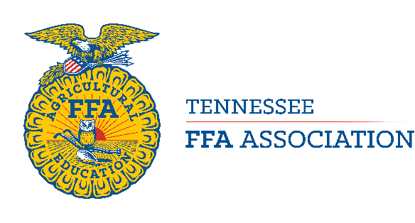

DATE: December 17, 2019
TO: Tennessee FFA Advisors
FROM: Regional FFA Consultants
RE: Nominating Committee Applications

The nominating committee to select the 2020-2021 Tennessee FFA State Officer Team will include six current FFA members, two from each region. The student committee members will be selected from applications submitted to the regional consultants. An application form is attached. Please encourage members to apply that you feel will represent the FFA in a positive manner and will be conscientious in the selection process.

In order for the process to work as designed, we need two quality committee members from each region. This will be an excellent learning process for any member and will be especially beneficial for any student who is thinking of running for a state office in future years. Pass this information on to your students.

Please review the enclosed application carefully. See below for method of submission based on your region. The completed application must be received by this deadline in order to be considered.

State Officer Nominating Committee
Application

Qualifications:
- Must be in the third or fourth year of active membership and currently a junior or senior in high school.
- Must have earned the Chapter FFA Degree.
- Only one application per chapter may be submitted.
- Chapters with a state officer candidate are ineligible to have a member serve on the nominating committee.

Schedule:
Jan. 15 East - Stena Meadows, email PDF application to Stena.Meadows@tn.gov
Jan. 16 Middle - Brad Parton, email PDF application to Brad.Parton@tn.gov by 11:59 P.M.
Jan. 16 West - Emily Grant, submit PDF application via West TN Dropbox by 9 P.M.
February 1 Approximate date committee members will be notified.
March 28 Committee members will meet at 1:00 pm in Gatlinburg.
March 29 Continue selection process.
March 30 Optional selection process meeting. (Committee members should not plan any convention activities prior to Monday morning. We will work around nominating committee member’s CDE events if a Monday meeting is needed.)
April 1 Nominating committee will meet at 7:00 am to complete the nominations.

Name:

Chapter:

Region:

Advisor(s):

Full Home Address:

Candidate Cell Phone Number:

Candidate Email Address:

Date received Chapter FFA Degree:

Number of active FFA membership years including this year:

This certifies that _____________________________ has a high school grade point average of ______________.

____________________________________
School Official’s Signature

List the twenty most important FFA activities you have participated in or awards you have received.

1.
2.
3.
4.
5.
6.
7.
8.
9.
10.
11.
12.
13.
14.
15.
16.
17.
18.
19.
20.

List the ten most important activities other than FFA you have participated in or awards you have received.

1.
2.
3.
4.
5.
6.
7.
8.
9.
10.

What leadership qualities do you possess that this nominating committee could benefit from? Also explain why you want to serve on this committee.

Describe the traits and characteristics that you would be looking for in a candidate for a state FFA office.

We certify that the information given in this application is true and accurate to the best of our knowledge. The candidate understands that all nominating committee plans, deliberations, and results are to remain confidential at all times during and following the interview process. Candidate agrees to maintain this information in strict confidence. Only the final results will be disclosed by the committee in the form of its slate of nominees.

________________________________ __________________________________
Nominating Committee Candidate Parent

Advisor’s statement verifying qualifications of this applicant:

I certify that the information given in this application is true and accurate to the best of my knowledge. I understand that all nominating committee plans, deliberations, and results are to remain confidential at all times during and following the process. I will not discuss or request information from a nominating committee member regarding the deliberations during or following the student’s participation. Only the final results will be disclosed by the committee in the form of its slate of nominees.

__________________________________
Advisor’s Signature

