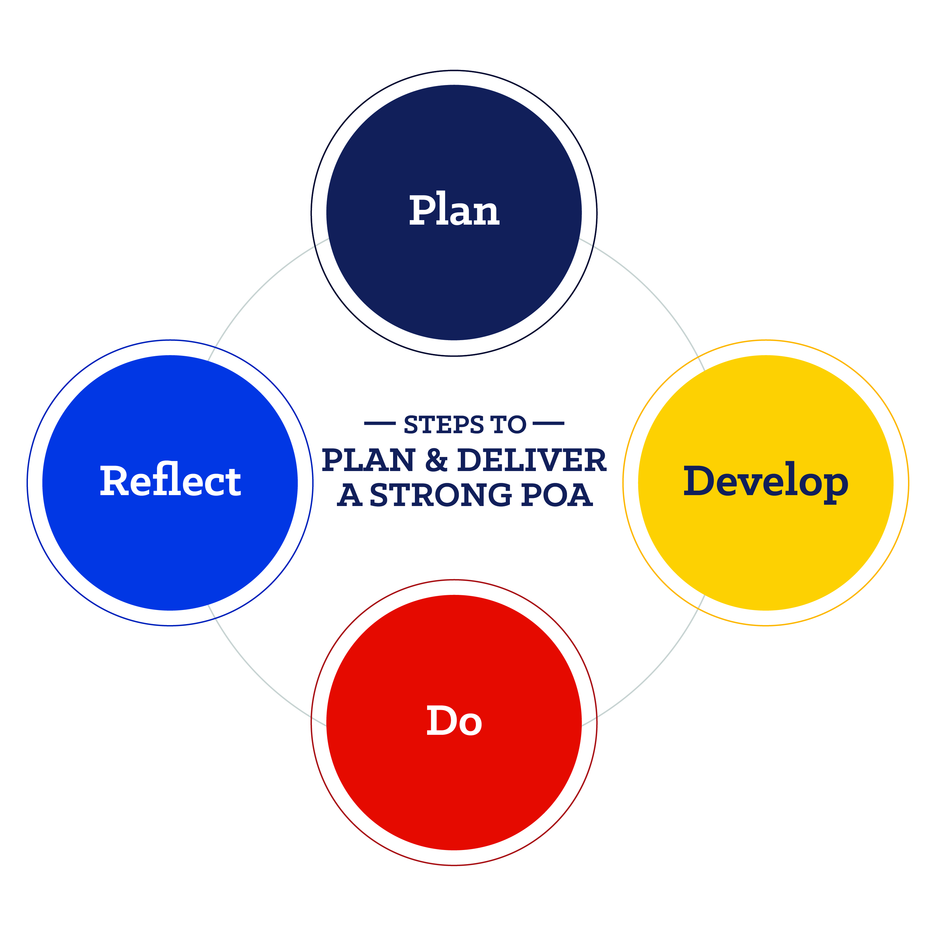
Program of Activities: Form 1 Summary
The Program of Activities (POA) serves to define chapter goals, outline steps needed to meet those goals and act as a written guide to provide a calendar of events the chapter will follow in the year ahead.
Growing Leaders | Building Communities | Strengthening Agriculture
Leadership Committee  Chair:  Activities: | Environmental Committee  Chair:  Activities: | Support Group Committee  Chair:  Activities:
Healthy Lifestyle Committee  Chair:  Activities: | Human Resources Committee  Chair:  Activities: | Chapter Recruitment Committee  Chair:  Activities:
Scholarship Committee  Chair:  Activities: | Citizenship Committee  Chair:  Activities: | Safety Committee  Chair:  Activities:
Personal Growth Committee  Chair:  Activities: | Stakeholder Engagement Committee  Chair:  Activities: | Agricultural Advocacy Committee  Chair:  Activities:
Career Success Committee  Chair:  Activities: | Economic Development Committee  Chair:  Activities: | Agricultural Literacy Committee  Chair:  Activities:
For more information on Program of Activities development, visit www.FFA.org/POA

