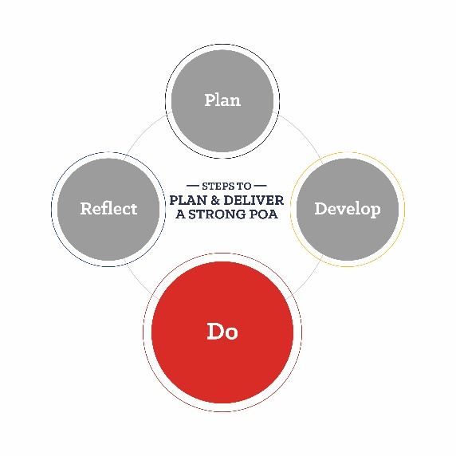
Program of Activities: Form 2
division:
Quality Standard:
Committee:
Activity:
committee Members Responsible:

Goals | Steps | Target Date | Estimated Financial Impact |  | Results/Notes
 |  |  | Expenses | Income

For more information on Program of Activities development, review the POA Resource Guide.

